**1: Kubernetes Architecture**

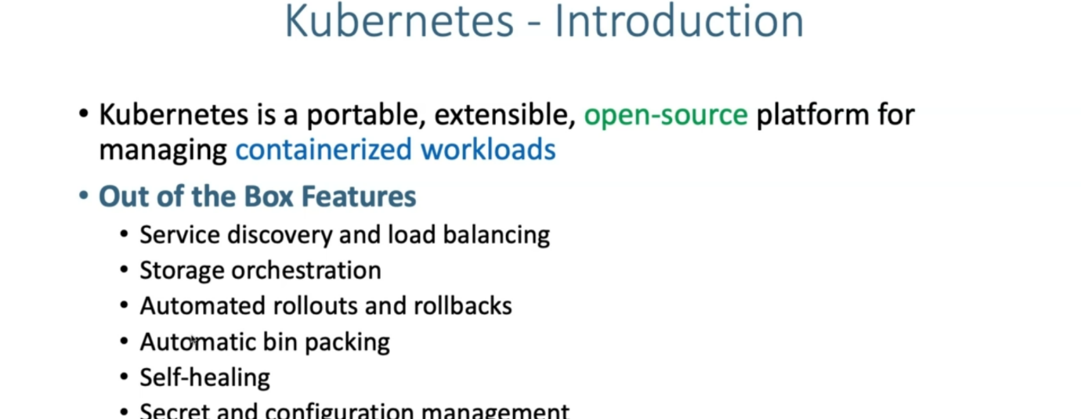

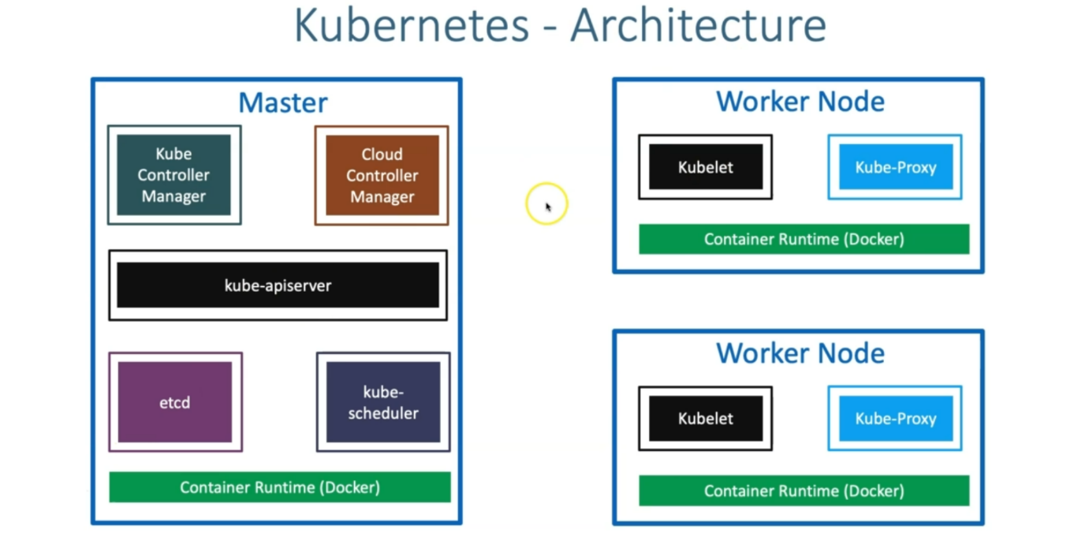

--- **note** - all these nodes, we'll have the container runtime install whether it is Master or worker nodes. container runtime is mandatory and we can say that whether it is docker or some other container runtime options.

--- **etcd** - etcd is the key value store, which stores the master and node information.

--- **master server components** – we have etcd, kube-schedular, kube-api server, kube controller manager, cloud controller manager. These are the components which are present inside of master server.

--- **worker nodes components** – **Kubelet** and **kube-proxy** is present on the worker nodes.

**Kubernetes architecture – master**

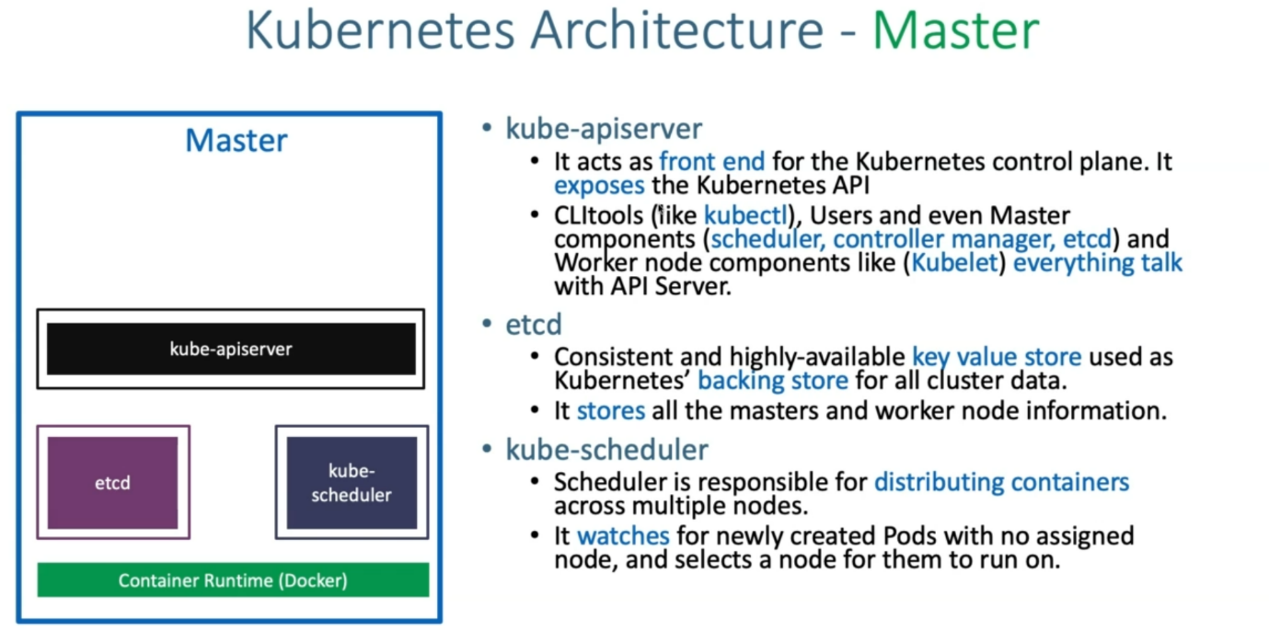

--- **kube-controller-manager** – below components are present inside of the kube-controller-manager.

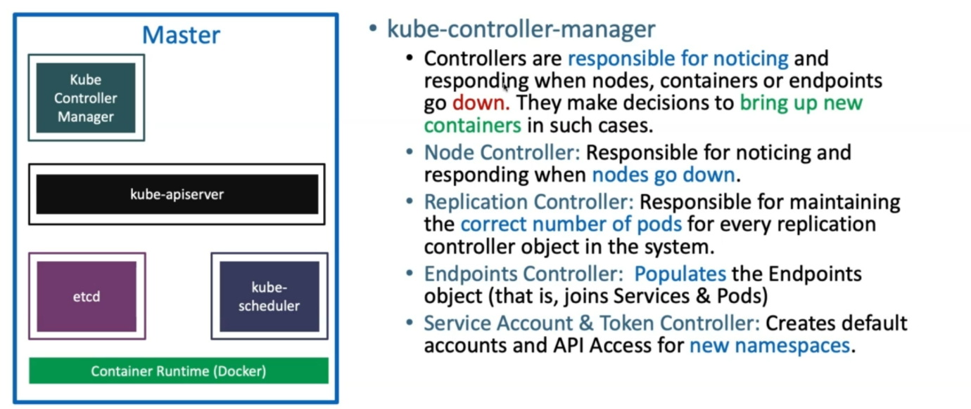

--- **cloud-controller-manager** - below components are present inside of cloud-controller-manager.

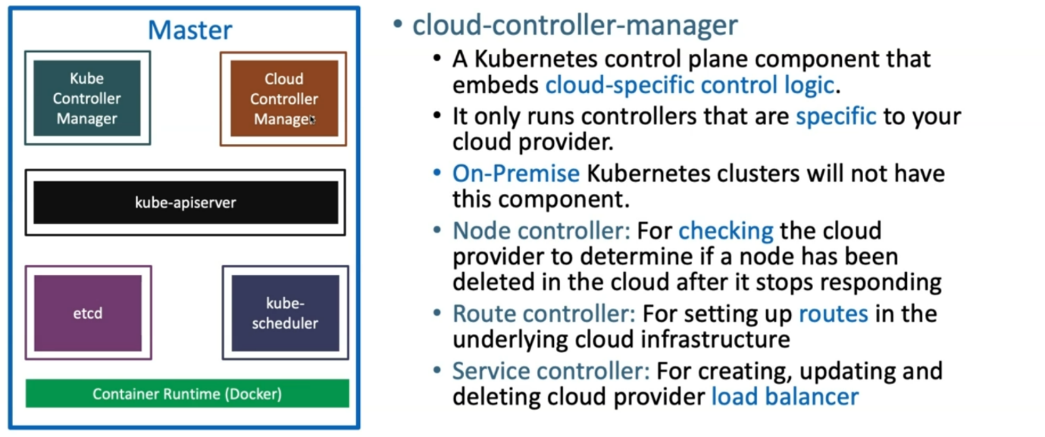

**Kubernetes architecture – worker nodes**

